2014 Unit 4 Past SAC 2 answers

Question 2
Which one of the following statements about enzymes is not true?

A. Enzymes can only be denatured by an increase in temperature.
B. Enzymes may form temporary ion-dipole bonds with substrate molecules.
C. Enzymes speed up reactions by holding substrate molecules in positions necessary for reaction.
D. The tertiary structure of an enzyme may be altered if one amino acid in its primary structure is
substituted for another different amino acid.

Question 4
The α-amino acid alanine has the molecular formula C₃ H₇O₂ N. If three alanine molecules react together to form a tripeptide, the relative molecular mass of this tripeptide would be:

- 89
- 231
- 267
- 283

Question 7
Olive oil contains a high proportion of oils made from a fatty acid called oleic acid. The number of double covalent bonds in oleic acid is:

- 0
- 1
- 2
- 3

Question 8
The formula of the amino acid serine at pH 9.0 is:

- ⁺H₃NCH(CH₂OH)COO—
- ⁺H₃NCH(CH₂OH)COOH
- H₂NCH(CH₂OH)COO—
- H₂NCH(CH₂O—)COO—

Question 9
The following diagram shows part of a protein molecule. At which point would the protein chain be broken during digestion?
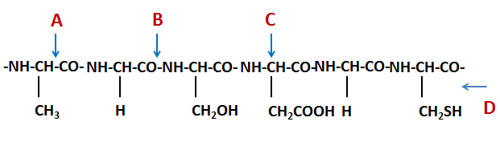
- At point A
- At point B
- At point C
- At point D

Question 11
The diagram below shows a section of a protein chain.
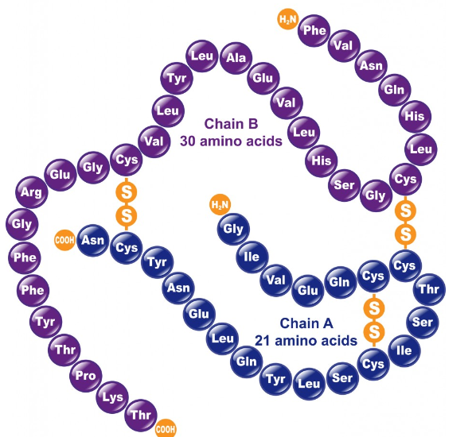
The bond between cysteine molecules (Cys) is used to maintain the

- Primary structure of a protein.
- Secondary structure of a protein.
- Tertiary structure of a protein.
- Primary, secondary and tertiary structures of a protein.

Question 12
Which of the following correctly describes the fundamental chemical structure of a strand of the DNA molecule?

A. Alternating phosphate groups and bases, with a sugar group attached to each base
B. Alternating sugar and phosphate groups, with a base attached to each phosphate group
C. A series of four bases, in sequences that determine what protein each segment codes for
D. Alternating sugar and phosphate groups, with a base attached to each sugar group

SECTION B

Question 4

a) The names, formulas, melting points and molecular masses for the fatty acids found in goat fat are shown in the table below.
Name | Formula | Melting point  (º C) | Molecular Mass
Caproic | C₅H₁₁COOH | -3 | 116
Caprylic | C₇H₁₅COOH | 16 | 144
Capric | C₉H₁₉COOH | 31 | 172

Explain why the melting point of a fatty acid increases as its molecular mass increases.
As the molecular mass of the fatty acid increases, the strength of dispersion forces between molecules increase. Therefore more energy is required to overcome them 1 mark.

b) The structure of a triglyceride found in goat is shown below.
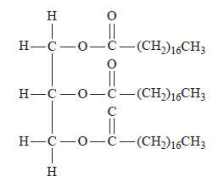
(i) Circle and name the functional group in the triglyceride molecule.
1 mark for circling the –COO- functional group; 1 mark for labelling ‘Ester’ linkage
(ii) Name the type of reaction when glycerol and the three fatty acids are reacted together to form the goat fat.

Condensation or esterification reaction 1 mark.
C₇H₁₅
C₉H₁₉
C₅H₁₁

c) Timnodonic acid is a polyunsaturated fatty acid found in the brain. The number of carbon-carbon double bonds in a molecule of Timnodonic acid can be determined by titration with iodine, I₂, solution. An addition reaction takes place between the double bonds in Timnodonic acid and iodine.
25.00 mL of 0.100 M I₂ solution reacted exactly with 0.151 g of Timnodonic acid. The molar mass of Timnodonic acid is 302.45 g mol^{–1}.

- Calculate the number of C=C bonds in a molecule of Timnodonic acid.
n(I₂) = c x V = 0.1 x 0.025 = 0.0025 mole 1 mark
n(Timnodonic acid) = $\frac{0.151}{302.45}=5 ×{10}^{-4}$ mole 1 mark
$\frac{n(I2) }{n(Timnodonic acid)}$:$\frac{0.0025}{5 ×{10}^{-4}}$ = $\frac{5}{1}$
Timnodonic acid has five C=C bonds 1 mark

There are 20 carbon atoms in a molecule of Timnodonic acid.
- What is the formula of Timnodonic acid?
C₂₀H₃₀O₂ or C₁₉H₂₉COOH 1 mark
Total = 8 marks

Question 5
a) The diagram below shows a small segment of another strand of DNA.

(i) and (ii) | (iii)
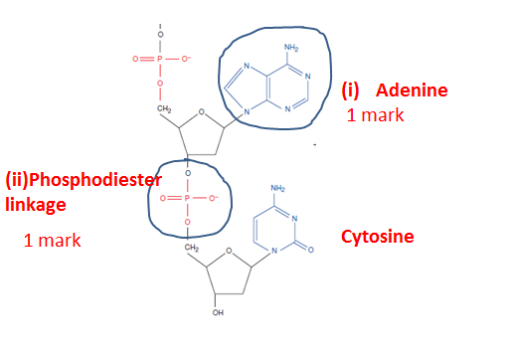 | 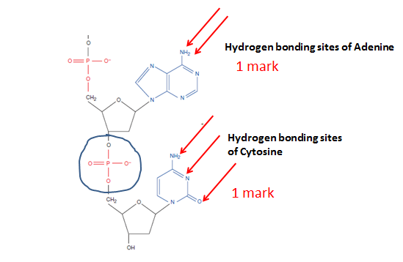

b) A double stranded DNA segment has a total of 180 base pairs. There are sixty thymine bases present. Determine the number of cytosine bases in the segment.
- There are a total of 360 bases present. There are 60 thymine and 60 adenine bases. There are 240 cytosine AND guanine bases present. Hence there are 120 cytosine bases 1 mark

Total = 4 marks

